Cloud Computing – Session 6
Advance S3 and Glacier

ASSIGNMENT - 2

SUBMITTED BY:
Mahendra M. Sunar

DATE: 13th July, 2017
Versioning and creating Lifecycle Policy for bucket.
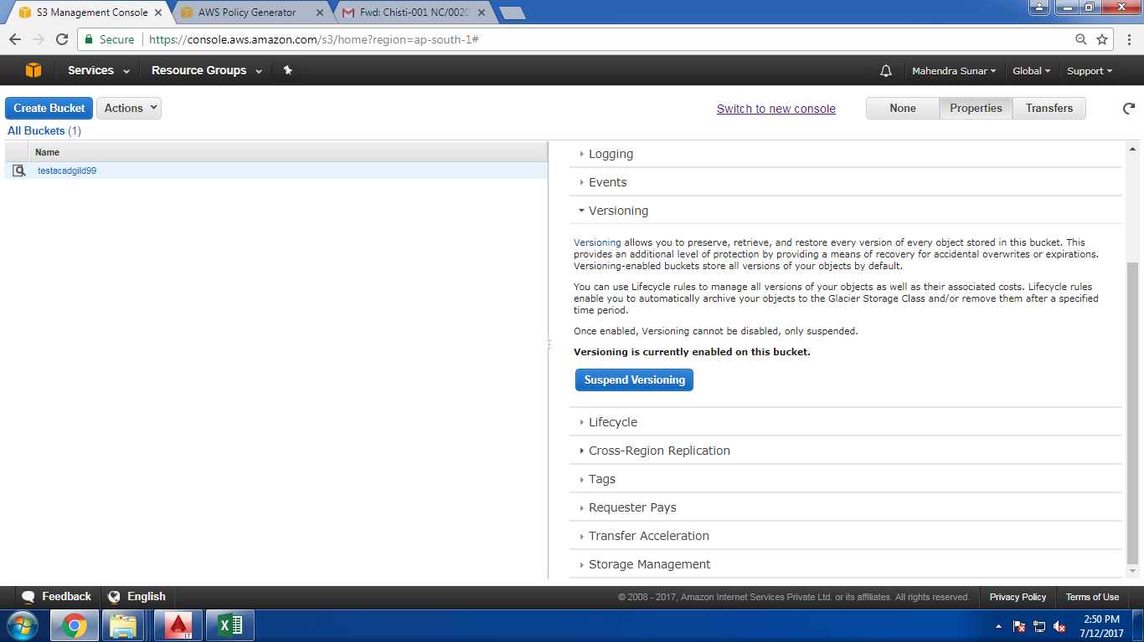
Creating Lifecycle Policy for Bucket
